SAGE Hardware Documentation Questionnaire

Part 1: Chassis & Mechanical Structure

1.1 Frame Overview
The structural integrity of SAGE relies on a hybrid design combining a rigid aluminum skeleton with high-strength 3D-printed components.

Dimensions and Mass
- Length: 615 mm
- Width: 629 mm
- Height: 625 mm

3D Printing Specifications
Most components were produced on a Bambu Lab A1 using the 0.20 mm "Strength" profile.

- Material: PETG (chosen for its durability and heat resistance).
- Wall Loops: 6 loops for increased structural rigidity.
- Infill: 25% infill.

Structural Components
The robot uses aluminum extrusions as the primary internal frame to prevent the chassis from flexing under the weight of the battery and motors.

Major Assemblies
There are eight distinct 3D-printed assemblies that make up the robot:
- Base Platform: The foundation of the robot.
- Middle Frame: The central structural shell.
- Lid: Houses the primary sensors (LiDAR, Camera).
- Wheel Brackets: Mounts for the front omni wheels.
- Motor Assembly: Houses the VersaPlanetary drive motors and Nidec encoders.
- Speaker Mount: Secures the audio system.
- Battery Holder: A reinforced frame for the 56-cell pack.
- Jetson Holder: A snug-fit mount for the primary computer.

Fasteners and Mounting
The robot is held together using a mix of imperial and metric hardware:
- Standard Structural Joints: 1/4-20 screws paired with nylon lock nuts for high-load areas.
- General Assembly: 8-32 screws for smaller printed components.
- Aluminum Integration: Metric T-nuts and M4 screws are used to secure printed parts to the aluminum extrusion channels.
- Jetson Orin Nano: Mounted using a friction-fit (snug) 3D-printed holder. This design allows for quick removal without tools while keeping the board secure during movement.
- STM32 Board: The MCU is mounted directly to the custom PCB breakout board via standard 2.54mm header pins, allowing for easy replacement or debugging if necessary.

1.2 Wheels & Drive System
The robot utilizes a differential drive configuration with a combination of traction wheels for power and omni wheels for maneuverability and precise tracking.

Drive and Support Wheels
The main movement of the robot is handled by high-traction rear wheels, while the front remains agile using passive rollers.
- Driven Wheels (Rear):
  - Model: 6in MAXSpline Hard Grip Wheel
  - Part Number: REV-21-2446
  - Details: 6-inch diameter, hard-tread material designed for consistent grip on flat surfaces.
- Passive Wheels (Front):
  - Model: 6in MAXSpline Omni Wheel
  - Part Number: REV-21-2476
  - Details: 6-inch diameter, allowing the front of the robot to slide laterally during turns for a zero-turn radius.

Dead Wheels (Odometry)
For high-precision position tracking, the robot uses a dedicated "dead wheel" system that is independent of the drive motors. This prevents wheel slip from affecting the robot's calculated location.
- Components: Two 4-inch omni wheels.
- Mounting: The wheels are mounted on pivoting arms attached to the aluminum frame.
- Ground Contact: To ensure the wheels never lose contact with the floor (which would cause tracking errors), a rubber band is tensioned on one end of the pivot. This creates a spring-loaded mechanism that constantly pulls the wheel against the ground.
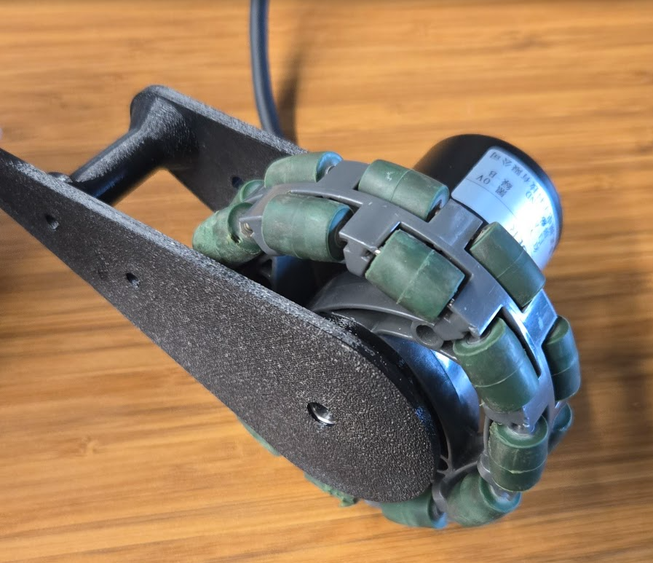
Figure 1. Dead wheel and encoder mounted to the pivoting arm

Drive Geometry
The distance between the wheels is a critical value for the robot's turning math.
- Wheel Track: The center-to-center distance between the two driven wheels is 0.381 m. This value is used by the firmware to calculate the robot’s heading and rotation.

Part 2: Electrical System & Power

2.1 Battery
Battery Specifications
The robot is powered by a custom lithium-ion battery pack. It uses 56 individual 18650 cells (Samsung 35E) arranged in a 4S14P configuration.

- Part Number: Samsung INR18650-35E
- Total Capacity: 49Ah
- Total Energy: 725Wh
- Voltage Range: 12V to 16.8V
- Maximum Discharge Rate (C-Rating): 2.29C
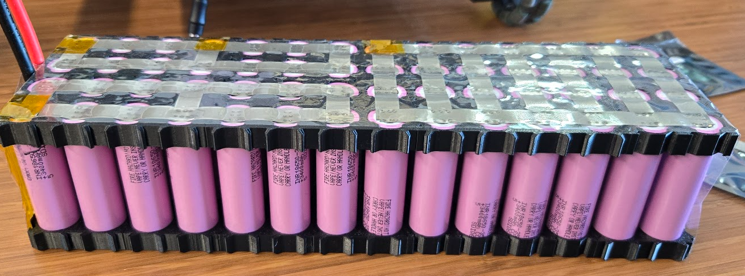
Figure 2. SAGE’s battery pack, arranged in a 4S14P configuration

Runtime and Maintenance
Expected Runtime: Approximately 12 hours under normal operating conditions.
Minimum Safe Voltage: The battery should be recharged before it drops below 12V (3.0V per cell) to ensure long-term health, though the BMS provides a hard cutoff at 10.2V.

Physical Installation and Connection
The battery is housed in a 3D-printed holder and is securely mounted to the robot’s aluminum frame.
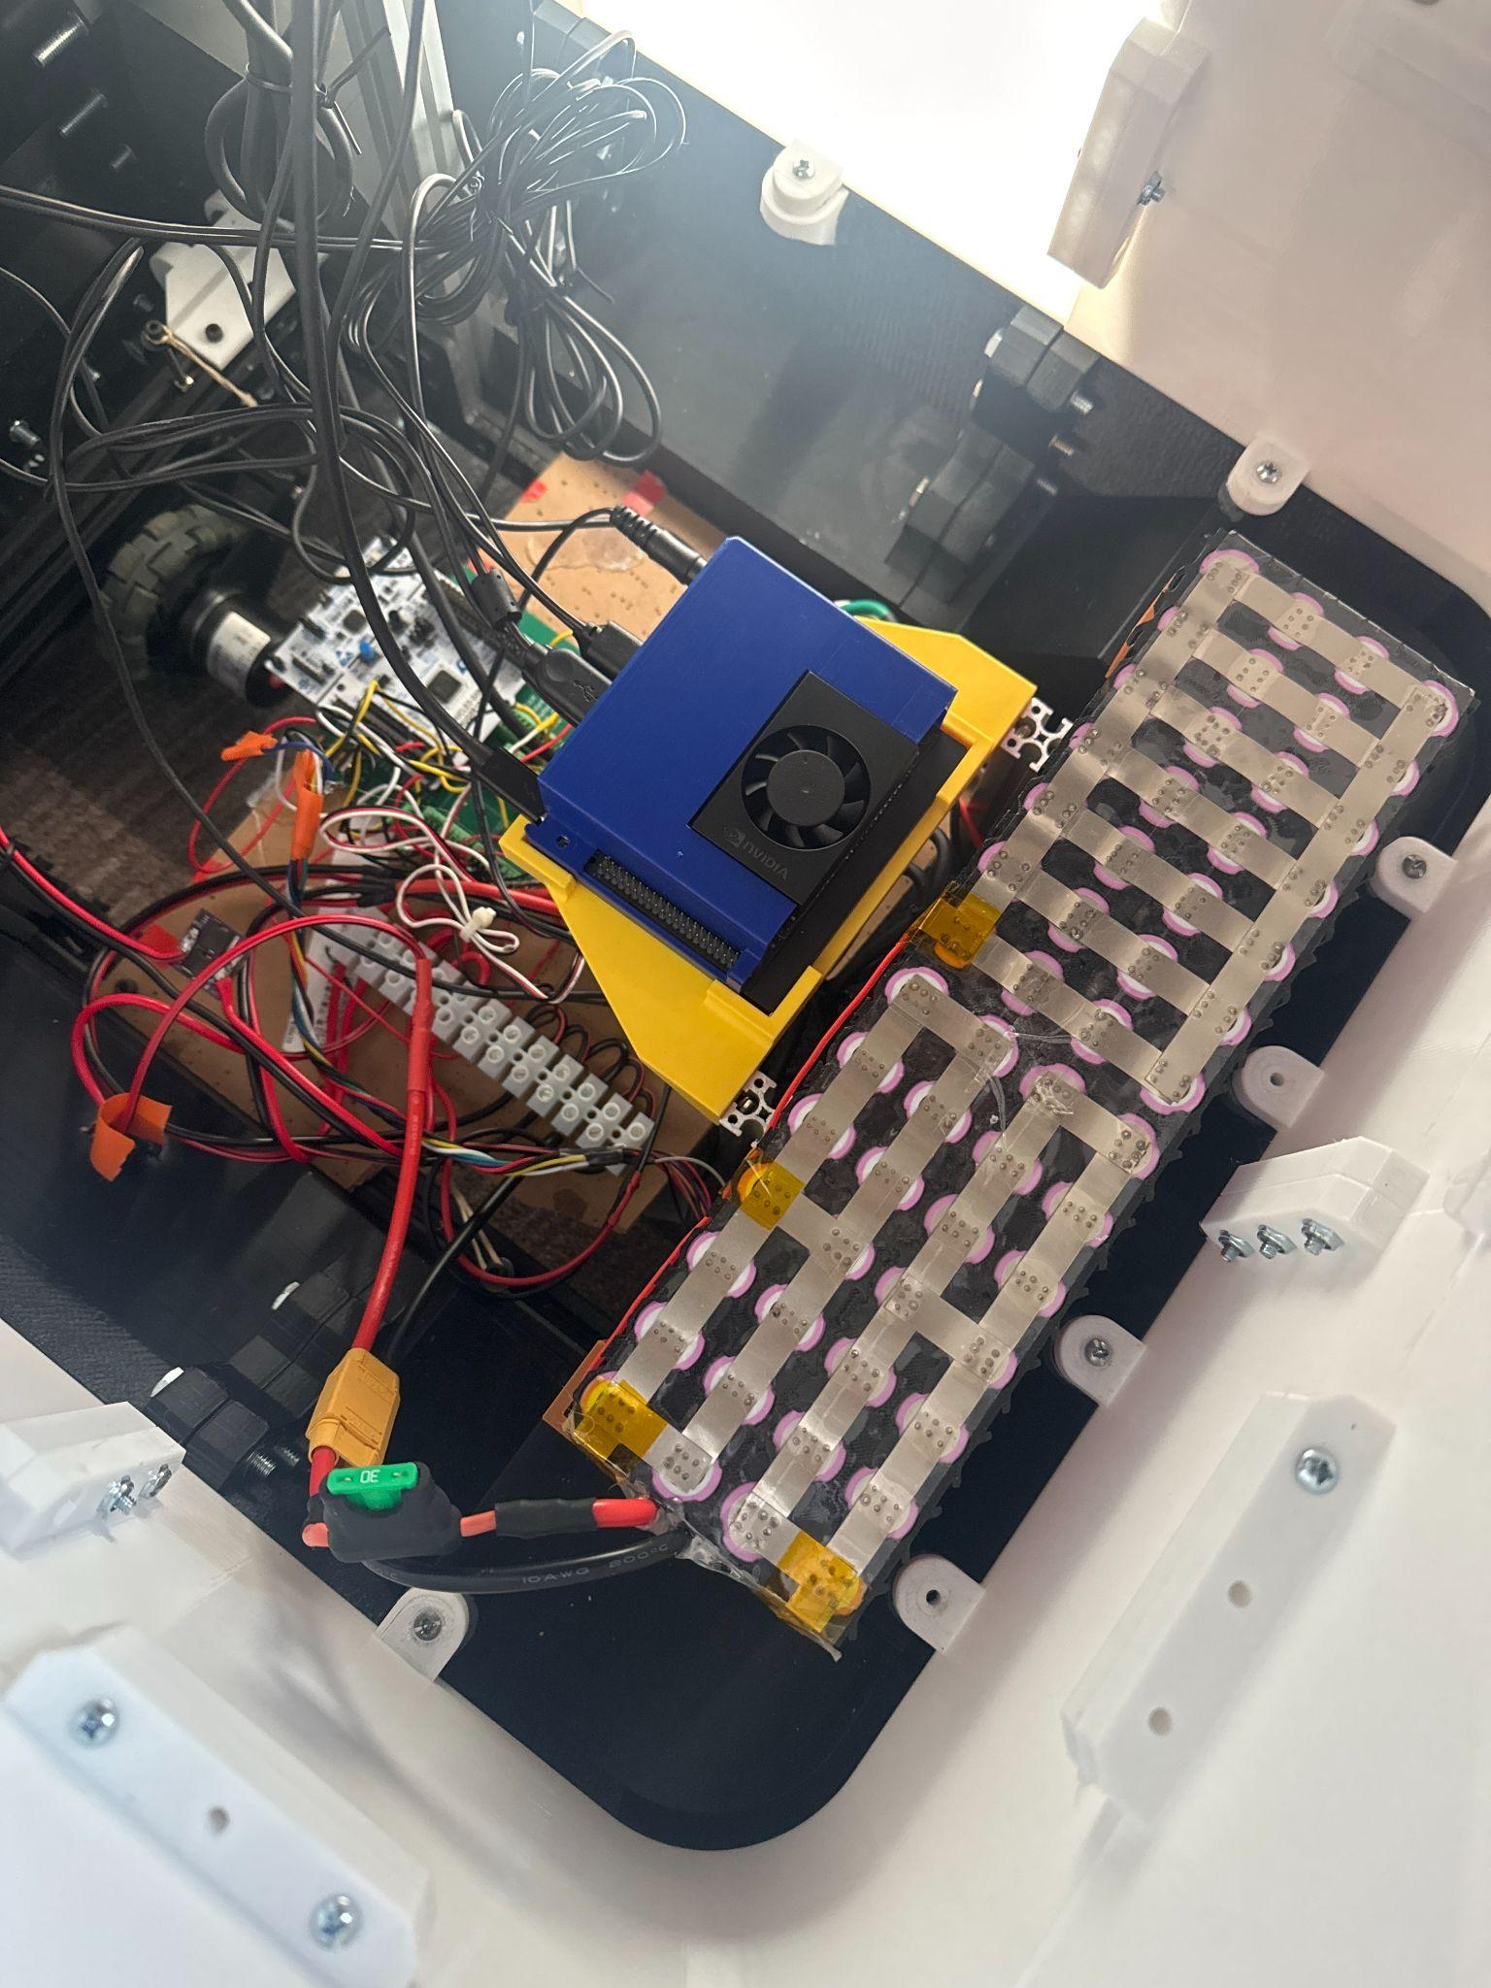
Figure 3. SAGE’s battery installed in the 3D printed holder above the real wheels

To distribute power:
- The cells connect through a Battery Management System (BMS) to a main fuse.
- A terminal block splits the power to the Jetson computer, motors, and other electronics.
- An ideal diode is used to manage the connection to the external charging contacts safely.

Battery Management System (BMS)
A protection circuit is installed to monitor the health of the cells. It handles balancing, short circuits, and temperature control.

Feature | Specification
Max Continuous Current | 30A
Over-Current Protection | 60A
Over-Charge Cutoff | 4.28V per cell
Over-Discharge Cutoff | 2.55V per cell
Operating Temperature | -30°C to +80°C

Charging Procedure
- Method: Contact-based charging.
- Max Charging Current: 10A.
- Procedure: The robot aligns its charging contacts with the dock. The internal ideal diode prevents back-feeding power while charging is in progress.

2.2 Power Distribution
The power system originates from the 4S lithium-ion battery pack and is distributed through a central terminal block. A 30A fuse is placed between the BMS and the terminal block for circuit protection.

Power Rails and Consumers
The system utilizes a direct battery rail for high-power components and regulated rails for sensitive electronics:

Main Battery Rail (12V – 16.8V):
- Jetson Orin Nano: Powered directly from the terminal block via the barrel jack.
- Motor ESCs: Connect directly to the terminal block to provide power to the drive motors.
- DC-DC Buck Converter (LEDs): Steps down battery voltage for the lighting system.
- DC-DC Buck Converter (iPad): Provides regulated power for iPad charging.
- Linear Voltage Regulator (MCU): Provides stable power to the STM32 board and encoders.
- Regulated 5V Rail (via Jetson USB):
- RPLIDAR: Powered through the Jetson's USB port.
- Speaker: Powered and audio-driven through the Jetson's USB port.

Component | Power Source | Connection Type | Voltage Level
Jetson Orin Nano | Terminal Block | Barrel Jack | Direct Battery (12V-16.8V)
STM32 (MCU) | Linear Regulator | PCB Terminal | Regulated Low Voltage
Drive Motors | Motor ESCs | Terminal Block | Direct Battery (12V-16.8V)
RPLIDAR | Jetson Nano | USB | 5V
Speaker | Jetson Nano | USB | 5V
LED Lights | Buck Converter | Terminal Block | Regulated Output
iPad | Buck Converter | Terminal Block | 5V (USB Standard)
Encoder | Linear Regulator | PCB Terminal | Regulated Low Voltage

2.3 Controls and Protection
Main Power Switch
- Type: Rocker switch.
- Location: Mounted on the robot body under the left side of the chassis.

Overcurrent Protection
- Main Fuse: A 30A fuse is located before the main terminal block to protect the entire system from shorts or surges.
- BMS Protection: The Battery Management System acts as a secondary failsafe with an integrated 60A over-current limit.

2.4 Motor System
Motor Specifications
The robot uses two VersaPlanetary motors (Part#: PM15R-25F-1001) for the drive system. These are high-torque motors paired with planetary gearboxes to handle the robot's weight and movement.
Electronic Speed Controllers (ESCs)
Both the left and right motors are controlled by identical ESC units.
- Calibration: These ESCs do not require a manual arming sequence or endpoint calibration; they are functional immediately upon receiving a valid signal.
- Connection: The ESCs connect to the STM32 microcontroller via standard PWM signal wires.
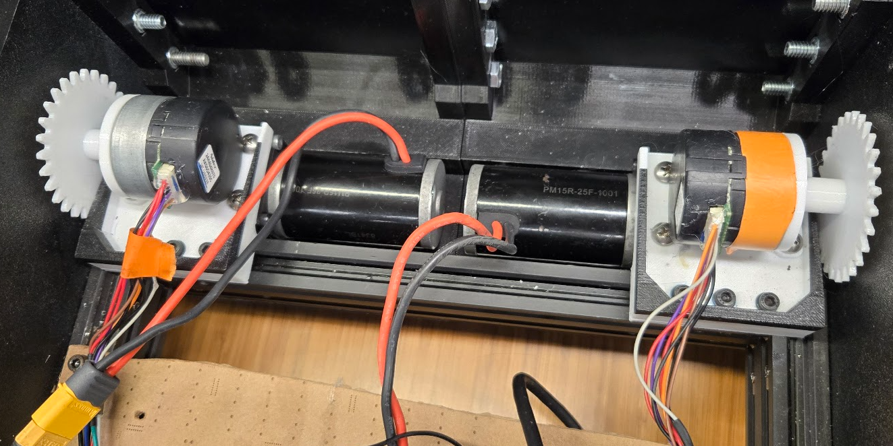
Figure 4. Two motors drive the rear wheels. The motors attach to the aluminum extrusion frame and encoders provide feedback for PID velocity control.

PWM Configuration and Signaling
The firmware uses specific timers to generate the signals that tell the ESCs how fast to spin.

Motor | Timer / Channel | GPIO Role
Right Motor | TIM15 / CH1 | PWM Output
Left Motor | TIM15 / CH2 | PWM Output

- Timer Settings: The prescaler is set to 63 and the Auto-Reload Register (ARR) is 19999.
- Signal Pulse Widths:
  - Forward Max: 1700 µs
  - Stop: 1500 µs
  - Reverse Max: 1300 µs
Note: These limits are hard-coded in the MCU firmware to ensure the robot operates within safe speed parameters.

Feedback and PID Control
While the robot's primary odometry (position tracking) is calculated using separate "dead wheels," the motor encoders are fully active.
- Hardware Interface: The STM32 reads these encoders via TIM3 and TIM4.
- Function: A PID controller uses this encoder data to ensure the motors accurately follow the commanded velocity, compensating for friction or slight differences in motor performance.

Part 3: Electronics & PCB

3.1 STM32 Board
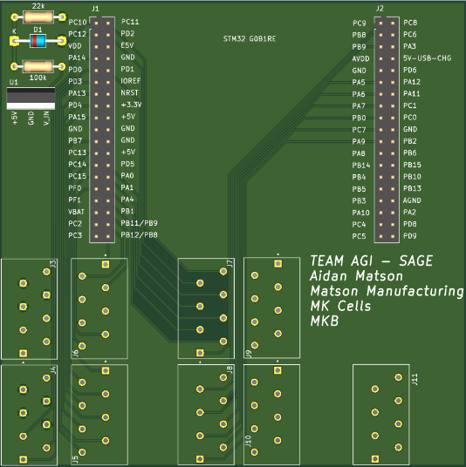
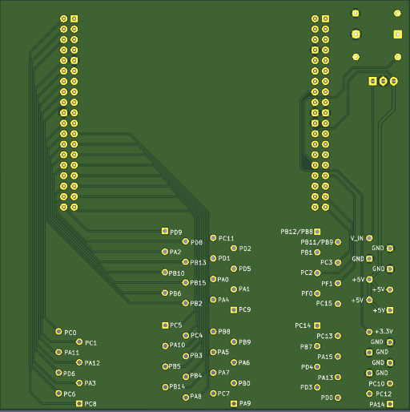
The robot uses an STM32G0B1 microcontroller. It is mounted on a custom PCB designed by Aidan Matson and manufactured through JLC PCB. This board allows secure connection to the MCU that is easily changeable

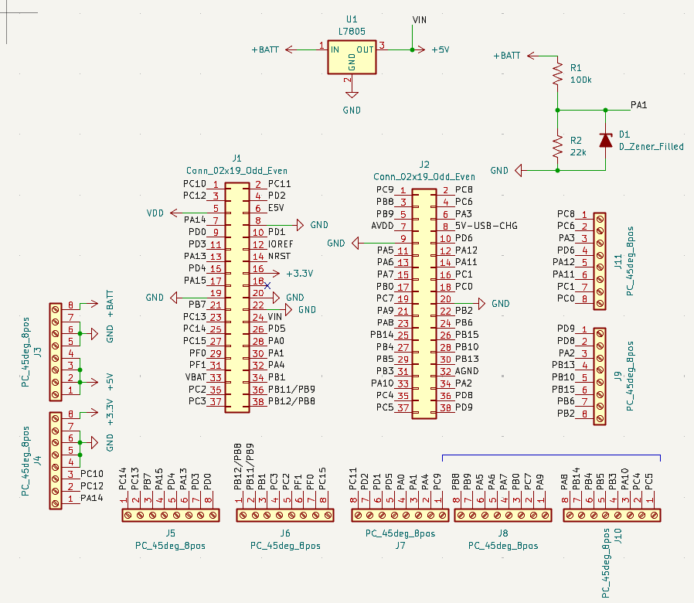
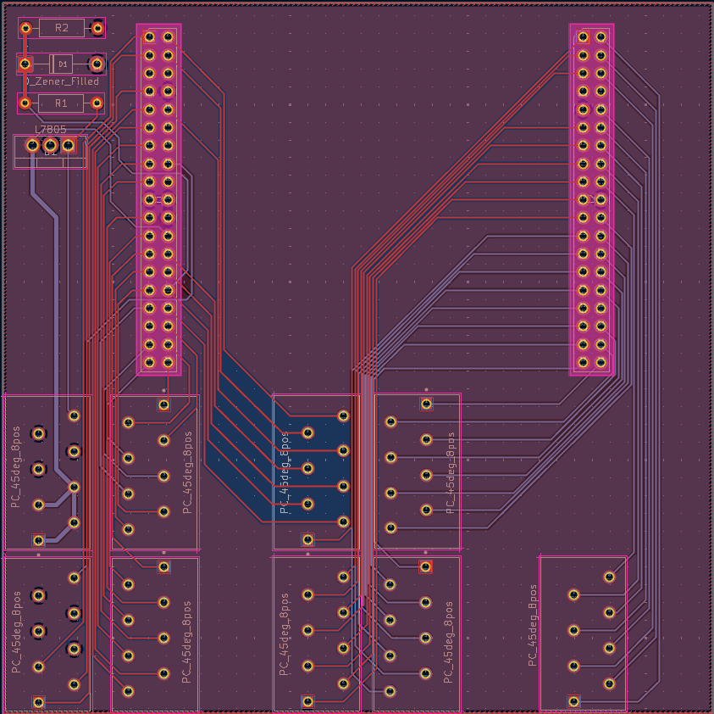

Connector Map
The following table images shows the physical connections on the custom PCB and the colors match the current wiring:
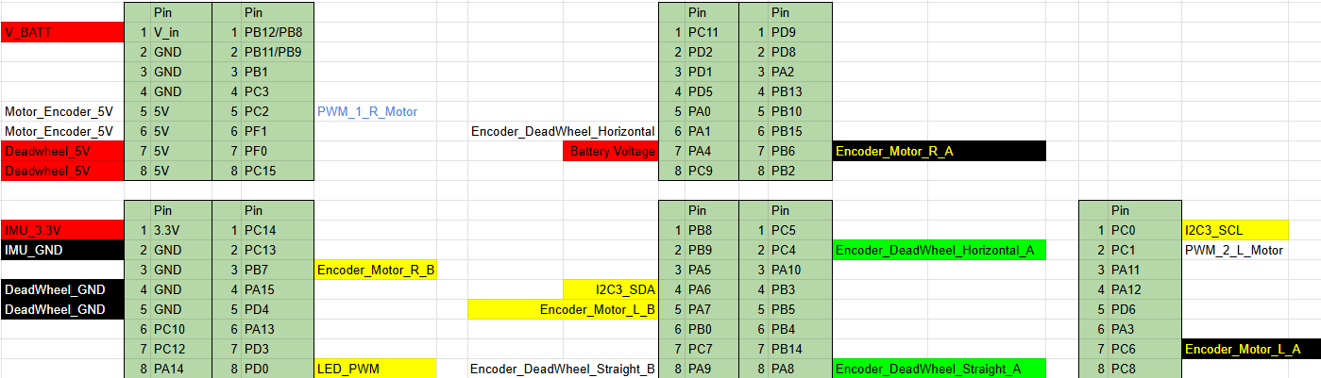

3.2 Wiring
Wire Management
Wires are primarily managed using cable ties to keep them organized. All cables are routed and secured to the frame to ensure they do not interfere with moving parts, such as the drive motors or the dead wheel assemblies. There are currently no known pinch points.
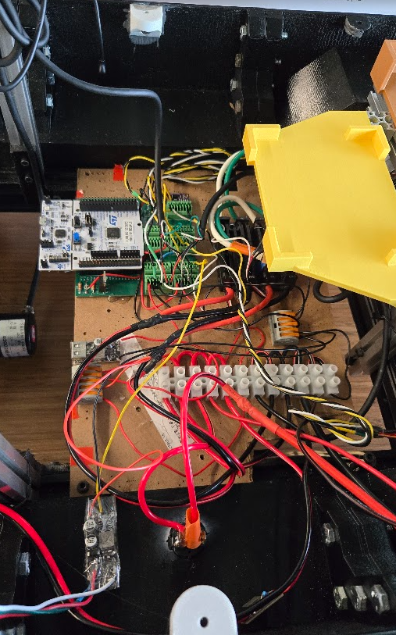

3.3 Encoder Wiring
The robot relies on two types of encoders for movement tracking and velocity control.

Dead Wheel Encoders (Odometry)
These encoders are used for high-accuracy position tracking.

- Model: Yosoo Health Gear Incremental Optical Rotary Encoder
- Resolution: 600 pulses per revolution (P/R)
- Voltage: 5V to 24V compatible (operating at 5V)
- Output: AB 2-Phase Quadrature

Motor Encoders (Velocity Control)
The drive motors use 2-phase optical encoders. While these were originally paired with Nidec 24H motors from a prototype phase, they are currently integrated into the VersaPlanetary drive system to provide feedback for the PID loops.

STM32 Hardware Mapping
All encoders utilize the STM32 Encoder Mode (Combined Channels) with an input filter set to 15 to eliminate signal noise.

Sensor | STM32 Timer | Configuration Notes
Straight Deadwheel | TIM1 | Uses internal GPIO pull-up resistors.
Horizontal Deadwheel | TIM2 | Uses internal GPIO pull-up resistors.
Left Motor Encoder | TIM3 | No external pull-ups required.
Right Motor Encoder | TIM4 | No external pull-ups required.
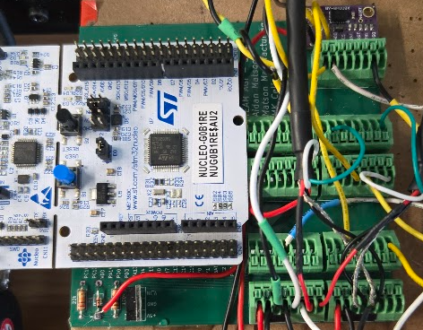

3.4 Battery Voltage Measurement
To monitor the health and remaining capacity of the 4S battery pack, the STM32 uses an onboard sensing circuit. This allows the robot to trigger low-voltage alerts or safe-shutdown procedures when the battery is depleted.

Hardware Implementation
The system uses a resistor divider to step down the battery voltage (up to 16.8V) to a level safe for the STM32's Analog-to-Digital Converter (ADC).
- Resistor Values: 100k and 22k.
- Sensing Pin: PA4 (ADC1, Channel 4).
- Voltage Scaling: The resistor network reduces the input voltage by a factor of (22/(100+22)), ensuring the signal stays within the 0V–3.3V range required by the MCU.

Software Calibration
To ensure the digital reading matches the actual physical voltage, the firmware applies a scaling constant and a specific correction factor.
- Correction Factor: 0.9848
- Accuracy: The measurement has been validated against a digital multimeter at both full charge (16.8V) and low charge (~12V) to ensure linear accuracy across the entire range.

Part 4: Assembly & Maintenance

4.1 Assembly Order
Assembling the robot follows a specific sequence to ensure all structural fasteners—particularly those using T-nuts—are accessible. Total assembly time from a bare chassis to a running state is approximately 3 to 4 hours.

Phase 1: Lower Chassis and Drive System
- 3D Printed Base: Begin by assembling the main 3D printed base plate.
- Aluminum Frame: Prepare the aluminum extrusion frame.
  - Insert all required T-nuts into the bottom channels of the extrusions before mounting them to the base. They cannot be added once the frame is seated.
- Drive Components: Install the front wheel brackets. Follow this by mounting the VersaPlanetary motor and encoder assemblies.
- Odometry: Attach the horizontal and straight dead wheel units to the aluminum frame.

Phase 2: Electronics and Power
- Main Board: Insert the custom STM32 PCB and mount it to the internal supports.
- Internal Wiring: Connect all motors, encoders, and sensors to the board according to the wiring table.
- Support Brackets: Install the battery holder frame and the Jetson Orin Nano mount.
- Audio: Secure the speaker holder into the chassis.

Phase 3: Middle Section and Table
- Shell Assembly: Assemble the middle section shell.
- Tablet Integration: Insert the Tablet before attaching the second layer of the shell; it cannot be added once the shell is closed.

Phase 4: Upper Lid and Sensors
- Sensor Mounting: Place the RPLIDAR and the camera into their respective mounts on the lid.
- Microphone: Install the microphone.
  - Note: Apply sound-deadening foam around the microphone during this step to minimize interference from motor and driving noise.

Phase 5: Final Integration
- Joining Sections: Attach the base assembly to the middle section.
  - Tip: This is easiest to perform while the battery is removed to keep the robot lightweight and prevent accidental shorts.
- Lid Attachment: Secure the lid and connect the final USB peripherals to the Jetson.

Required Tools
Full assembly and disassembly can be performed with a small set of standard tools:
- Phillips Head Screwdriver: The primary tool for most housing and component fasteners.
- Metric Hex Key Set (Allen Wrenches): Required for the aluminum frame bolts, wheel components, and motor mounting.

4.2 Critical Fastening Notes
To maintain structural integrity during operation, the robot utilizes specific locking mechanisms and adhesives to prevent parts from loosening due to vibration.

Thread-Locking and Mechanical Fasteners
- Thread-Locker (Blue Loctite): Applied to high-vibration areas, specifically the screws securing the drive wheels and their internal components. It is also used on the bolts that mount the deadwheel assemblies.
- Nylon Lock Nuts (Nyloc): For all other structural mounting points where Loctite is not used, nylon lock nuts are the standard to ensure permanent tension.
- Maintenance Note: Whenever a wheel or deadwheel component is removed for service, the old Loctite should be cleaned from the threads and a fresh drop applied before reassembly.

Adhesives and Fitments
- Hot Glue: Used as a secondary retention method for various electronic components and connectors (such as the motor encoder JST plugs) to prevent them from shaking loose.
- Interference Fits: Several wheel components are designed with tight tolerances. These parts are press-fit and require a slow, even application of force to "work" them onto or off of their respective shafts or housings to avoid damaging the material.

4.3 Removing and Reinstalling the Jetson
The Jetson Orin Nano is the high-level processing unit of the robot. For maintenance tasks such as WiFi reconfiguration or firmware updates that require a direct connection, follow the procedure below.

Removal Procedure
Because the Jetson is not held in place by mechanical fasteners, it can be removed quickly. However, care must be taken with the cabling to avoid stressing the ports.
- Power Down: Ensure the main rocker switch is in the OFF position.
- Disconnect USB Peripherals: Unplug the Micro USB cable leading to the STM32 and the USB cables for the RPLIDAR and Speaker.
- Disconnect Power: Unplug the barrel jack from the side of the Jetson.
- Lift and Remove: Gently lift the Jetson unit vertically out of its mounting position.

Connector Risks and Precautions
- USB Ports: The USB ports are standard but can become loose over time if the cables are pulled at an angle. Always pull straight out.
- Barrel Jack: This is the most robust connector, but ensure the wire is not snagged on the frame before lifting the unit.
- Static Safety: As with all exposed electronics, try to touch a grounded part of the aluminum frame before handling the Jetson to discharge any static electricity.

Once the Jetson is removed, it can be connected to an external monitor and keyboard via HDMI and USB.

- WiFi Interface: The Jetson uses a standard Ubuntu-based network manager.
- Procedure: Log in to the desktop environment to update SSID and password credentials for a new network. After configuration, the unit can be placed back into the robot; it will automatically reconnect to the new network upon the next boot.
- You can also ask SAGE for her current IP address.

Part 5: Safety & Handling

5.1 Electrical Safety
Safety precautions must be followed whenever the robot's internal compartments are accessed, particularly when the battery is connected.
- Stored Energy: Even after switching the rocker switch to the OFF position, the capacitors in the Motor ESCs remain charged at several volts for approximately one minute. Wait for this discharge period before touching electrical contacts.
- Short Circuit Risk: While the system includes a 30A fuse and BMS protection, you must never manually short the positive and negative terminals. The high capacity of the 14P cell arrangement can cause immediate damage or fire if shorted.
- Live Maintenance: If working on the robot while the battery is connected, use insulated tools and avoid wearing conductive jewelry (rings, watches).

5.2 Battery Handling and Storage
The custom 4S14P lithium-ion pack requires specific care to maintain safety and longevity.
- Storage Charge: If the robot will be inactive for more than two weeks, the battery should be discharged or charged to approximately 50% State of Charge (SOC).
- Temperature Limits: Do not charge the battery if the ambient temperature is below 0°C (32°F). Avoid storing the robot in high-heat environments (above 60°C/140°F), such as a car in direct sunlight.
- Physical Integrity: Inspect the battery holder regularly for cracks. If the battery pack is dropped or punctured, remove it from the robot immediately and place it in a fire-safe container (such as a sand-filled bucket) away from flammable materials.

5.3 Operational Hazards
SAGE is a powerful mobile platform; operators and technicians should be aware of physical risks during movement.
- Pinch Points: The primary hazard is the drive wheels. Keep fingers, loose clothing, and hair away from the underside of the chassis when the motors are armed.
- Speed Limits:
  - Calculated Maximum: The physical drive system is capable of higher speeds, but it is software-limited to 1.5 m/s for normal operation.
  - Collision Risk: There are no mechanical hard stops or bumpers that will prevent the robot from hitting an object. While the RPLIDAR provides data for obstacle avoidance, the robot will not physically stop itself if the software fails to command a stop before an impact.
- Crush Hazard: Due to the weight of the battery pack and the torque of the VersaPlanetary motors, SAGE can easily crush small objects or cause tripping hazards if operated in a crowded environment.

